Caged animals are safe, but it is not much of a life
  - Dunning-Krueger effect versus intentional evil.

Robert W Malone MD, MS
Aug 28

[Malone, and has, with the assistance of his wife, Jill, for several months been methodically framing “The Big How” and “The Big Why” questions and digging into related sciences for the best and brightests' research results as to known tools that appear to have been used to effect the COVIDcrisis.–FNC]
I returned late last night from speaking at the Gateway for Freedom conference, which was held at the Gateway Conference Center in Collinsville, IL (suburb of St. Louis). Why was it held in Collinsville, Illinois you ask? Because not a single conference venue actually located in the city of St. Louis would allow it to be held in the city, as the speakers and topics to be discussed were not acceptable. So the conference organizers had to go across the river to a venue in Illinois. That is where this all has come to. The words of Drs. Peter McCullough, Robert Malone, Richard Urso and Ryan Cole are so dangerous that they should not be heard.
Many attendees asked me a question that I also find deeply troubling. Why have we, all of us, all over the world, been subjected to these profoundly destructive and counterproductive “public health” polices since January 2020. All the same policies, same justifications, same words, same censorship, same actions, all over the western world. Is it due to incompetence on the part of “public health officials” (but globally harmonized?), due to some evil pre-conceived global plan, or due to various powerful groups who seek to exploit a viral infection to advance their economic, geopolitical, or other power-related objectives? This is what I call “The Big How” question, and was first posed to me by Bret Weinstein on the infamous June 14, 2021 Dark Horse Podcast “How to Save the World in Three Easy Steps” (which once could be found here, but no longer, as it apparently violated YouTube’s Community Guidelines). Three old men sitting around a table talking for three hours was clearly an unacceptable “threat to democracy” (ignoring for the moment that the USA is a republic, not a democracy). “Threat to Democracy” is the boogie man/fear porn language that is repeatedly trotted out to justify censorship by Obama, the corporate media, the World Economic Forum, and a wide range of apologists who reside all over the world (including the WHO and the WEF- which organizations are most decidedly not democratic).
The one hour version of the pivotal “How to Save the World” podcast can be found here. The full podcast can now be found here.
“The Big How” question clearly requires multiple choice answer format. Can I please be allowed to select “all of the above” as my answer? Without being concern trolled with accusations of being “controlled opposition”? Thanks. Moving on now….
Jill and I listen carefully to our readers and those that we meet during our travels, and always learn from the valuable feedback that is freely given. While at the “Gateway for Freedom” conference, I had one participant come to me with what I call “The Big Why”, and another told me how much she appreciates our publications discussing various aspects of the (dysfunctional) psychology that has driven the arbitrary and capricious policies which we have all been subjected to.
What is the motivation behind what the various globalist overlords have done to us? Just as “The Big How” appears to be multifactorial, at a minimum combining incompetence and (truly evil) exploitation of the “opportunity” presented by the outbreak (leavened by clear evidence of pre-planning), this is also the case with “The Big Why”. Unfortunately, I lack the ability to read minds, and have not been invited to the inner planning meetings of the globalist overlords, so I can only formulate multiple working hypotheses and infer which of those hypotheses have merit based on the data at hand. Unlike those who have been “black pilled” and who conclude overwhelming grand conspiracies as the explanation for everything having to do with the COVIDcrisis, I try to constrain my interpretations by the boundaries of the verifiable.
In other words, there is no way that I can provide any definitive answer to “The Big Why” while still maintaining what shreds of intellectual objectivity I can still clutch around me like pieces of torn cloth in an effort to retain some degree of professionalism and dignity. I choose to leave it to others to provide their versions of the simple grand unifying explanation. Not to say that any of these are either false or true. I just have no way of knowing which is which. And unless you have been brought into the “inner circle” of the globalist overlords (or are one of the 4,000 who have achieved the 33rd level of Scottish Freemasonry, or one of the illuminati or of the tribe of lizard people?), I suggest that you are in the same boat that I am trying to paddle. I have heard second hand stories of high status hereditary leaders having been warned in 2019 that the global economy was about to be shut down for a period of years, and that they should prepare for such. So who knows. Maybe there are vampires, and I have just never (knowingly) encountered one. Hard to disprove theories like this.
However, both you and I can learn from various scholars of political science and psychology who have spent lifetimes studying and understanding behavioral and psychological phenomena which can help both of us to at least make some sense out of what we have been subjected to. Probably you are like me, and would like to see those who have done these truly evil things to humanity be held accountable for their actions. But in this aspect, I am afraid that I have been “black pilled”, and decades of observing the culture of the WHO, the Imperial Capital (Washington DC) and their administrative state actors has lead me to adopt a rather nihilistic point of view concerning the likely of any of the guilty being held accountable. Please prove me wrong.
In prior presentations and Substacks, we have together explored a variety of psychological and political science theories which I believe can help make sense out of the otherwise confusing and non-sensical aspects of the COVIDcrisis.
These include
- At the macro level, there has clearly been a large scale psychologic process involving the formation and hypnosis of a large fraction of the population who fervently believe the “Approved Narrative” that SARS-CoV-2 is highly lethal across all age cohorts, that early treatment with a variety of both newly developed and repurposed lifesaving drugs does not work, and that the genetic “vaccines” which cause your body to manufacture the spike protein of SARS-CoV-2 are both fully safe and effective. You can find our Substack essays concerning academic theories which explain this (Mass Formation, or Mass Psychosis, or Mass Formation Psychosis) here, here, here, here, here, and here is an essay regarding the denialism of Google, which is guilty of having driven the development of the effect. And of course, there is the deeply academic analysis of the effect published by my colleague the world-renowned Professor of Clinical Psychology Mattias Desmet (The Psychology of Totalitarianism). As stated in the overview to the book
“The world is in the grips of mass formation—a dangerous, collective type of hypnosis—as we bear witness to loneliness, free-floating anxiety, and fear giving way to censorship, loss of privacy, and surrendered freedoms. It is all spurred by a singular, focused crisis narrative that forbids dissident views and relies on destructive groupthink.”
Discussion of the large scale psychological manipulation tools and processes which have been deployed globally on an unsuspecting and uninformed populace would be incomplete if the work of Joost Merloo was not cited (see this video for a quick introduction), as well as “Nudge: Improving Decisions About Health, Wealth, and Happiness” (you can read one of our substacks regarding deployment of “Nudge” technology here). Big tech, corporate media, governments and transnational organizations such as the WEF, WHO and UN all actively deploy “Nudge” technology to manipulate the unsuspecting. Much of what is commonly called “Woke” programming involves “Nudge” manipulation. And of course there is the BBC-lead “Trusted News Initiative”. If you are not familiar with the TNI, please watch the linked video.
- Moving to a more micro level, the small group psychopathology of the elite insular decision making groups who have been determining public health policies at the national and transnational (ergo WHO, UN, WEF) level is very consistent with the processes and predictions which Dr. Irving Janus described in his seminal book (first published in 1972) “Groupthink: Psychological Studies of Policy Decisions and Fiascoes”. This has been covered in various interviews and in substack essays which can be found here and here.
- Then we get down to the truly micro level: individuals who are responsible for the decisions which have caused deep harm to so many, despite their denialism. Dr. Anthony Fauci has come to embody the psychopathology shared by so many who bear responsibility for the profound death, disease and financial devastation which they have wrought. As exhibit #1 supporting a diagnosis of narcissism, I offer both the famous “I am the Science” as well as his recent self-own regarding “The Fauci Effect”. Narcissistic Personality Disorder: Narcissistic personality disorder (NPD) is a cluster B personality disorder defined as comprising a pervasive pattern of grandiosity (in fantasy or behavior), a constant need for admiration, and a lack of empathy. Signs and symptoms include a grandiose sense of self-importance. Does the diagnosis of many of these individuals extend to sociopathy or psychopathy? This video can help you to make your own evaluation: “Narcissist, Psychopath, or Sociopath: How to Spot the Differences”. For those who want to know more about how Psychopaths and Sociopaths often rise to lead oppressive political movements, I recommend “Political Ponerology: A Science on the Nature of Evil Adjusted for Political Purposes”, which the publisher describes as “shocking in its clinically spare descriptions of the true nature of evil. It is poignant in its more literary passages revealing the immense suffering experienced by the researchers contaminated or destroyed by the disease they were studying. Political Ponerology is a study of the founders and supporters of oppressive political regimes. Lobaczewski s approach analyzes the common factors that lead to the propagation of man’s inhumanity to man.”
But what about just plain incompetence?
Could the policies of the last two-plus years be nothing more than the Dunning-Krueger effect? That is evidently what Debbie Birx, the White House Coronavirus Response Coordinator under Trump - appears to express in her final analysis of what has happened.
Remember this testimony exchange between Congressman Jim Jordan and Dr. Deborah Birx? Dr. Birx’ prior experience primarily involved oversight of the US Army HIV (including HIV vaccine development) program, as well as the George Bush PEPFAR program. She is not trained in public health, or experienced with either respiratory RNA virus virology or immunology. But she certainly understood how hard it can be to safely develop a vaccine.
Remember her various explanations regarding “HOPE” as a basis for her policy decisions?
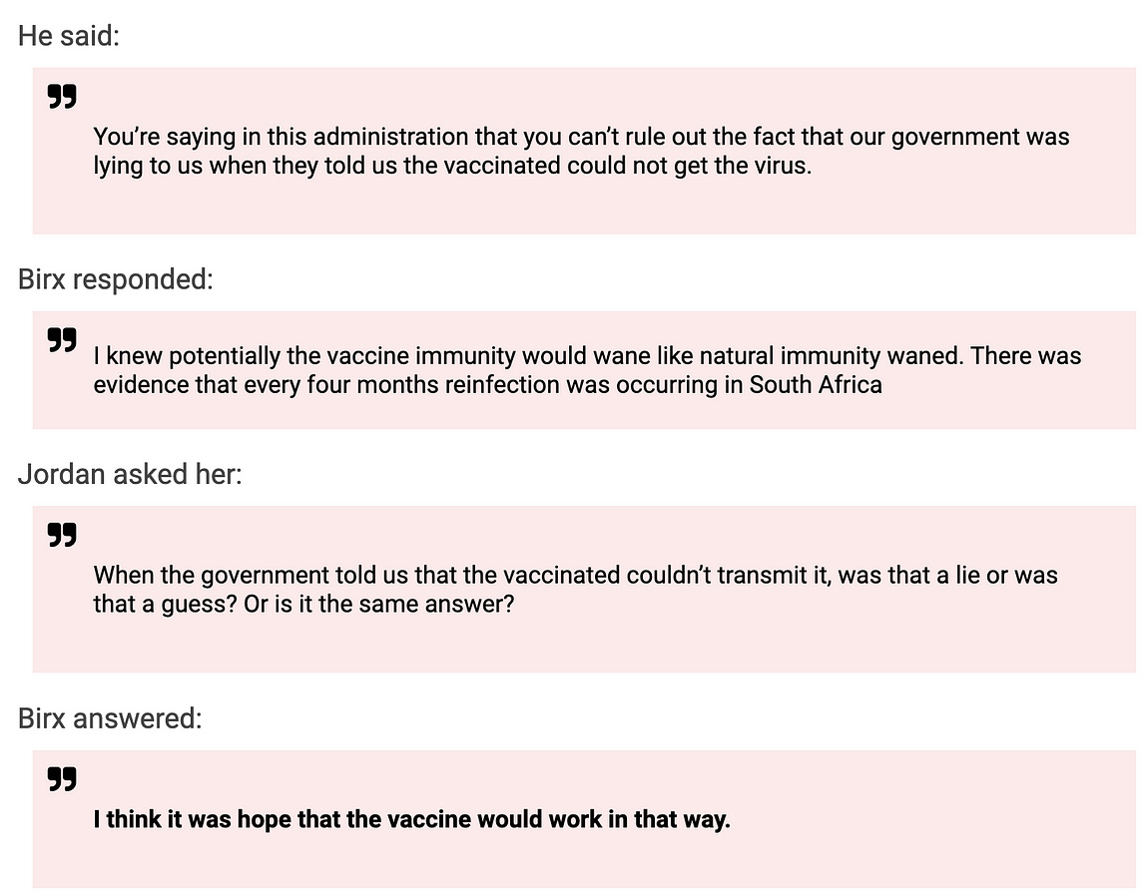
Then remember that these COVID-19 policies were built on what we now know were “LIES”.

Looping back to the big picture, there is the idea that what has been happening globally is just the beginning of something very dark, very intentional, and very planned. Is there any way that either you or I can know for certain if this is the case? Unfortunately, no. But that does not mean that we should not be aware that this hypothesis is most definitely consistent with the observable facts.
As Neil Oliver says:

“Caged animals are safe, but it is not much of a life”

Could it be that our top government officials were really were so ignorant and devoid of skill- that they fell into the trap of Dunning-Krueger? That high perceived ability from those with little knowledge led to poor decision making?

What is the Dunning-Krueger effect?

Unskilled and unaware of it: how difficulties in recognizing one's own incompetence lead to inflated self-assessments
J Pers Soc Psychol. 1999 Dec;77(6):1121-34. doi: 10.1037//0022-3514.77.6.1121.
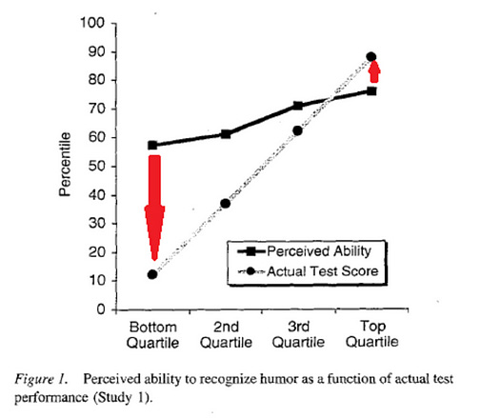
Abstract
People tend to hold overly favorable views of their abilities in many social and intellectual domains. The authors suggest that this overestimation occurs, in part, because people who are unskilled in these domains suffer a dual burden: Not only do these people reach erroneous conclusions and make unfortunate choices, but their incompetence robs them of the metacognitive ability to realize it. Across 4 studies, the authors found that participants scoring in the bottom quartile on tests of humor, grammar, and logic grossly overestimated their test performance and ability. Although their test scores put them in the 12th percentile, they estimated themselves to be in the 62nd. Several analyses linked this miscalibration to deficits in metacognitive skill, or the capacity to distinguish accuracy from error. Paradoxically, improving the skills of the participants, and thus increasing their metacognitive competence, helped them recognize the limitations of their abilities.

In the video below, Neil Oliver describes a darker theory. That this was purposeful and that the planned destruction has only just begun. That there is evidence- that this is not some poorly thought out, poorly designed plan, but something much more sinister.

“Ruinous Policies” (and not just COVID)-
“We are being groomed to live small lives.
as the wealthy hover up the rest of the Wealth”
“This is about wealth and power.”
Neil Oliver 'Blood in the Water' Video [11 ½ munutes. If in a hurry, still listen to the first 5 munutes! Chilling, but worth the time. Note that Robert Malone puts this 'darker theory' into the right perspective: Just another theory to explain “The Big Why”. –FNC]

It all comes down to collectivism versus individual rights.
Do you want safety and a cage or do you want freedom? Maybe you are not in the 10 - 20% that values freedom (with all of the burdens and responsibilities that come with the package), or maybe you just want to be told what to do.
Who gets to decide?
“Caged animals are safe, but it is not much of a life”
This is powerful stuff -
Let’s discuss.
What are your hypotheses for “The Big Why” which has lead to the profound death, damage and destruction which we have all experienced since January of 2020?
Please share your thoughts, comments, conclusions or questions in the comments below.
<And by the way, a moment of silence for the “Wikispooks” wiki, formerly located at
https://wikispooks.com/ , which I had previously found very useful, but which now has been completely scrubbed from the corporate and intelligence community-controlled internet. Welcome to the Brave New World.>
Who is Robert Malone is a reader-supported publication. To receive new posts and support my work, consider becoming a free or paid subscriber.
Upgrade to paid

